RECIPE FINDER

GROUP NUMBER: 19
Rohit Siripurapu (11802342)
Nikhitha Muthyala (11801043)
Anuraag Akuthota (11816197)
Yasaswini Konapalli (11819994)
Keerthan Podila (11816794)
Date of submission: 8th September 2024

- EXECUTIVE SUMMARY :

The Recipe finder Git Hub (https://github.com/hayleyarodgers/recipe-finder?tab=readme-ov-file) is a recipe search engine that displays meals based on the ingredients searched by the users and views recipes from an external API, However, this project lacks some functionality that enhances user experience, where user can customise their recipe and plan their meal, Our team goal is to improve this project and enhance the user experience by improving the UI for the project and add some features, including user profile creation, meal scheduling, Advance search filters, and recipe – sharing platform, these additional features will enhance the application make it more interactive and user friendly.

A team of five individuals will develop this project and it is expected to be completed within the next 8-10 weeks, This estimation includes designing, developing, testing, enhancing, and solving any errors (if there are any). As it is an open-source project, the project's cost will be minimal or less.

2. PROJECT DESCRIPTION :
Nowadays, people often strive to cook meals based on wholesome, fresh ingredients they have. At the same time, millions of recipes are available online and in books. Users are overwhelmed with many options and require more advanced tools to plan and organise their meals. The existing git hub project lacks features that cater to personalised meal scheduling and recipe management. Our project goal is to enhance the features of Recipe Finder, which will meet the user's needs by providing an all-in-one platform for discovering recipes, managing user recipes, and sharing recipes from one user to another. This project will help users to plan their meals, find new recipes and share their recipes with other users.

3. GOAL:

The goal of this project is to enhance the current recipe finder web application by adding the following enhancements and features:
- Ui and UX design enhancement
- Authentication - To add user authentication with a secure login credential.
- Profile customisation - Enables users to create, edit, and customise their recipes.
- Advanced search filters -Implement advanced search filters where users find the recipes that will meet their requirements.
- Add meal plan - This feature allows users to schedule their meals for specific days.
- Dark mode
- Customer Feedback

Note - The current version of this project is quite basic. Our team aims to enhance the UI and UX design, as well as introduce additional features to provide a more seamless and user-friendly experience.

4. REQUIREMENTS:
- Need to change the current UI and UX interface to make it more user-friendly.
- Need to build secure user authentication to create and edit personalised profiles.
- Improve the current search engine to be advanced
- Need to build meal-planning tools for users that include calendar dates.
- Dark mode accessibility for user preference

ARCHITECTURE:
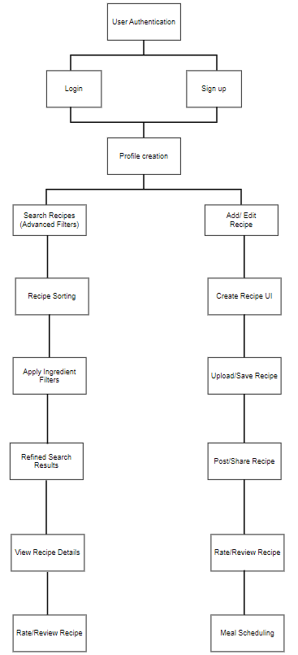
Fig. Architecture diagram
Architecture Diagram:
When the user launches the application, they will see a user authentication page where they can login or sign up if they are using this application for the first time. If the user is signing up, they must create a profile where they have to give basic information about themselves. After creating the profile, now the user can access two features of the application, such as searching the recipes or creating a new recipe.

For searching the food recipes, the user must provide the name of the ingredients that they have. There are three columns provided for entering the name of the ingredients; if there are more, the user can increase the columns using a plus button. After entering the ingredients, the application will show the list of recipes that can be made with the ingredients that the user has given. The user can also filter out the recipes by choosing the filter option, where there is a list of options by which the user can sort the recipes, such as filtering out by reviews and rating, popularity, and cooking time. Therefore, the user can now choose the recipe they want to try, and the application will give them the details about how to prepare that recipe. The user now can give their feedback by giving ratings and writing their review on the recipe.

For creating a new recipe, the user has two options: to create a new recipe or use the existing one. For creating a new recipe, the user should give the list of ingredients required and the step-by-step process for making the recipe. After creating a new recipe, the user should save and upload the new recipe into the application so that other users can also access the information about the recipe. The ratings and reviews that are given by other users can be seen by everyone, including the one who created the recipe.

5. APPROACH AND SOLUTION -

- Front-end development: For front-end development, the UI will be designed by using HTML, CSS, and JavaScript frameworks like React.js for faster responsiveness and interactivity.
- Back-end development: The current version does not have any user authentication; we will add user authentication and profile management by using Node.js with a MongoDB database. User data, including saved recipes and meal plans, will be stored securely.
- Meal scheduling feature: Users will be able to drop and add recipes to their own calendar based on selected meals. This function will be developed by using Java and the calendar API.
- Advanced search engine: The current search is only limited to showing food videos; we will implement filters based on dietary preference and show ingredient information.
- Recipe Sharing: We will implement a feature where users can upload their recipes and leave and rate other recipes.

6. DELIVERABLES:

- The entire web application can be completed and delivered within 12 weeks of the duration (duration schedule mentioned below):

- User authentication and profile creation: in the first 4 weeks, our team will work on a feature that allows users to sign up, sign in, and create their profile (1-4 weeks).

- Improved UI and UX design: For week 5, our team will work on improving the UI and UX design through better optimisation.

- Meal scheduling: For the advancement of the web application, we will work on adding a meal scheduling feature where users can plan their meals (weeks 6–8)

- Advanced Search Filters: Enhanced search functionality based on user preferences and provided ingredients, etc

- Recipe sharing feature: In the last phase, our team will work on a feature that enables users to share and edit their recipes (weeks 8–10).

- Final testing and deployment: We will test and address any issues and deploy the web application

